

PROJECT NAME

Electronic City Phase 2, Opp.HCL, Bangalore-100

A Project Report On

College Management

Submitted in Partial Fulfilment of the Requirement Of the 5th Semester of “Bachelor of Computer Applications” **(BCA)** By Bangalore University, During the Academic year 2014-2015.

Under The Guidance of Prof. MALLINATH (HOD OF BCA)

Submitted By :

MANJUNATH M (124KSB6010)



IZEE

COLLEGE OF MANAGEMENT

AND INFORMATION SCIENCE

Electronic City Phase 2, Bangalore-100

**A PROJECT REPORT ON**

Virtual Campus

COLLEGE MANAGEMENT SYSTEM

Submitted In partial Fulfilment of the Requirement For the 6th Semester of “Bachelor of Computer Applications” (BCA) By Bangalore University, During the Academic Year 2014-2015.

Under The Guidance Of

**Prof. BALAKRISHNA**

(HOD of BCA)

Submitted by:

**MANJUNATH M (124KSB6010)**



CERTFICATE

This Is To certify, **MANJUNATH M (124KSB6010) of The 6th Semester BCA**

**(BACHELOR OF COMPUTER APPLICATIONS),** has satisfactorily completed

The Software Engineering Lab Project entitled **“COLLEGE MANAGEMENT”**

As Prescribed By the Bangalore University from Our Institution During

The year 2014-2015.

**Lecture In Charge Head Of The Department**

**External Examiners**

**PLACE:**

**DATE:**

DECLARATION

We the Students Of 6th semester BCA**, IZEE college of management and**

**Information science,** Bangalore, Hereby declare that dissertation entitled

**“COLLEGE MANAGEMENT”** Has Been Developed By the Individual Member

**MANJUNATH M** for the partial fulfilment of the requirements for the 5th

Semester of **BACHELOR OF COMPUTER APPLICATIONS** by the Bangalore

University during the Academic Year 2014-2015.

Further, The Matter for Embodied in The Dissertation has not been submitted

Previously by anybody for the award of any degree or diploma to any other

University.

DATE:

PLACE: BANGALORE MANJUNATH M

ACKNOWLEDGEMENT

ACKNOWLEDGEMENT

We Extend Our Gratitude towards our Head Of The BCA Department And

Our Project Guide Prof. MALLINATH for his valuable guidance throughout

The Course Of This Project.

I Am Thankful to each and every person who Has Helped In The Successful

Completion Of This Project.

Thankfully,

**MANJUNATH M**

CONTENTS

CONTENTS

1. **SYNOPSIS**
2. **AIM**
3. **SYSTEM REQUIREMENTS**
4. **INTRODUCTION TO SOFTWARE**
5. **OVERVIEW OF THE SOFTWARE**
6. **ABOUT VISUAL BASIC 6.0**
7. **ABOUT MCROSOFT ACCESS**
8. **E-R DIAGRAM**
9. **DATABASE STRUCTURES**
10. **FORMS**
11. **SOURCE CODE**
12. **TEST CASE AND TESTING**
13. **CONCLUSION**
14. **BIBLIOGRAPHY**

SYNOPSIS

SYNOPSIS

The Implementation of computers in each and every field of life made the

Life much easier. The work became more efficient, accurate & less complex.

Our Project Comes Under The category Of Application Programs in Which We

Trues to reduce the human efforts in “COLLEGE MANAGEMENT” and creating

Smooth flow of work.

AIM

AIM

The Aim of This Project Is to Computerize the recording, Processing and

Documentation of student data in college.

SYSTEM REQUIREMENTS

SYSTEM REQUIREMENTS

* Software Requirements :
* **Operating Systems**
* Windows 98
* Windows XP (Up to Service Pack 3)
* **Front End Tool :**
* Microsoft Visual Basic 6.0 Enterprise Edition
* **Back End Tool :**
* Microsoft Access
* Hardware Requirements :
* CPU : Dual Core
* Memory : 512 MB +
* Hard Disk : 50 GB
* Printer : Dot Matrix 24 Pin, 180 Columns

INTRODUCTION TO PROJECT

INTRODUCTION TO PROJECT

This Project Is Meant For Creating an Application Software to Do the Various

College Management Tasks. It Covers Areas like Registering Student, Storing

The Student Information, Updating Student Details, Keeping Track of Student

Details, Collecting Fee and Keeping Track Of Fee Collected in Order to Make

Audits Easy, Managing Daily Attendance, Managing Student Scholarship Etc…

Enhanced Administrative Features and Enhanced Security for a Software And

Database, Data Backup Facility, Internet browsing Facility for the One Click

WWW Connect & Made Scholarship Registration easy.

OVERVIEW OF THE PROJECT

OVERVIEW OF THE SOFTWARE

.

.

In This Chapter We Present a Review of the Software Used While Implementing

The Project. The Software Is VISUAL BASIC 6.0 Enterprise Edition as Front End

Tool and MS ACCESS as Back End. Thus We Will Take An Overlook On This Software.

Mainly My Project Is Having Following Modules.

* Login Form
* User Log Intelligence
* User Management Forms
* Student Management Forms
* Attendance Management Forms
* Fee Payment Management Forms
* Scholarship Management Forms
* IntelliSense Internet Browser
* Reports :
* User Secure Login Report
* Student Information Report
* Scholarship Tracking Report

ABOUT MS-ACCESS

Microsoft Access Is a Database management tool Which Has Been Introduced

As A Part of Microsoft Office. It Enables Us the Easy Creation & Manipulation

Of Databases. Its Graphical User Interface Allows us To Easily Handle each &

Every Function without Any Prior Knowledge.

ABOUT VISUAL BASIC

Visual Basic Is an Ideal Language for Developing Sophisticated Professional

Applications for Microsoft Windows Operating Systems. Visual Basic Is An

Powerful Development Platform that you can use to create Rich Applications

For Windows 95 and NT (New Technology) Operating System quickly and easily.

It is easy for novices to program in visual basic with professional results.

It makes use of Graphical User Interface for Creating Robust & Powerful

Applications.

ER DIAGRAM

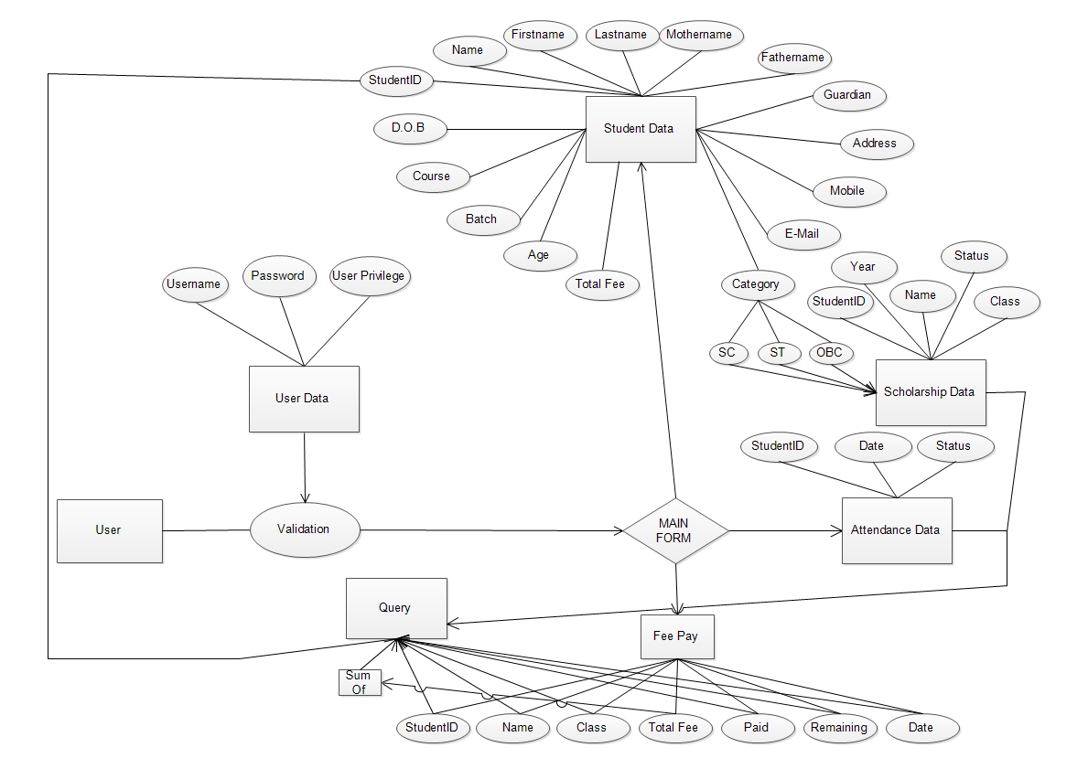

DATABASE TABLES

TABLES

1. **Table Name : Login**

|  |  |
| --- | --- |
| **Field Name** | **Data Type** |
| Uname | Text |
| Password | Text |
| Acc_type | Text |

1. **Table Name : UserLog**

|  |  |
| --- | --- |
| **Field Name** | **Data Type** |
| UserID | Text |
| SessionStart | Text |
| SessionEnd | Text |
| Description | Text |

1. **Table Name : AttendanceBCA, AttendanceBBM, AttendanceBCOM**

|  |  |
| --- | --- |
| **Field Name** | **Data Type** |
| Register Number | Text |
| Date | Date/Time |
| Status | Text |

1. **Table Name : STUREG , BCOM , BBM**

|  |  |
| --- | --- |
| **Field Name** | **Data type** |
| StudentID | Text |
| FirstName | Text |
| MiddleName | Text |
| LastName | Text |
| MotherName | Text |
| FatherName | Text |
| GuardianName | Text |
| PermanentAddress | Text |
| City | Text |
| State | Text |
| PinCode | Number |
| ContactNumber | Number |
| MobileNumber | Number |
| EmailAddress | Hyperlink |
| Photograph | Text |
| Gender | Text |
| BirthPlace | Text |
| DOB | Date/Time |
| Nationality | Text |
| Age | Number |
| NamePS | Text |
| AddPs | Text |
| CoursePs | Text |
| YearOfPassing | Number |
| PromoPS | Text |
| DoAdmission | Date/Time |
| Class | Text |
| Section | Text |
| RollNo | Text |
| ReationshipWithStudent | Text |
| Occupation | Text |
| AnnualIncome | Text |
| No_DependentsInFamily | Text |
| PhoneHome | Text |
| PhoneOffice | Text |
| Religion | Text |
| Caste | Text |

|  |  |
| --- | --- |
| MotherTongue | Text |
| Category | Text |
| Sub_Category | Text |
| Total_Fee | Text |
| Fee_Paid | Text |
| Remaining_Fee | Text |

1. **Table Name : ScholarshipTracker**

|  |  |
| --- | --- |
| **Field Name** | **Data Type** |
| RegisterNumber | Text |
| StudentName | Text |
| Class | Text |
| ClassYear | Text |
| Category | Text |
| SubCaste | Text |
| Status | Text |
| Amount | Text |

1. **Table Name : BCAFEE , BCOMFEE , BBMFEE**

|  |  |
| --- | --- |
| **Field Name** | **Data Type** |
| StudentID | Text |
| StuName | Text |
| Class | Text |
| Total Fee | Currency |
| Paid | Currency |
| Remaining | Currency |

FORMS AND REPORTS